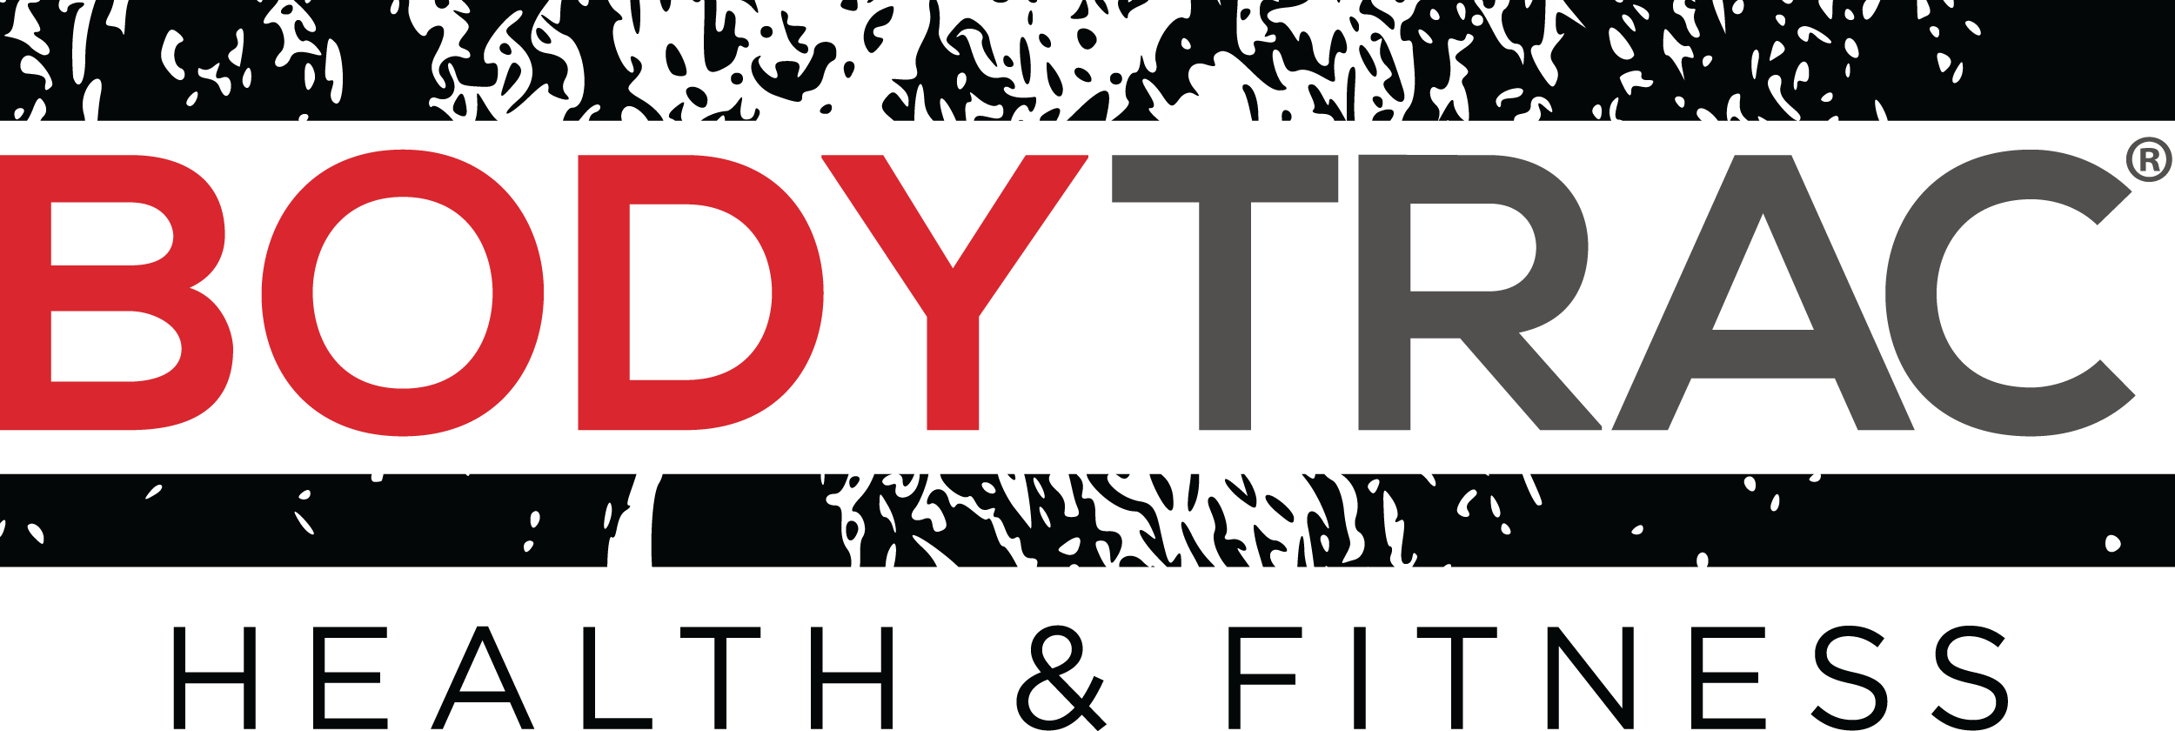

“Motivation is what gets you started and habit what gets you going”

YOU CAN DO IT! IT WILL JUST TAKE SOME TIME.

Your self-confidence got you here, to this place of commitment and dedication! When you have high self-confidence you can lose weight easier because you believe in yourself. Now that belief is your driving force, patience should be your guide. Weight loss will not happen overnight, so pace yourself and PUSH on!

NO MORE EXCUSES!

There are 100’s of excuses why you cannot start a diet or why you can’t go to the gym today. Committing to this challenge, you just threw them all out the window! Whenever you think of an excuse try to transform it to an opportunity to do something that will make your proud tomorrow.
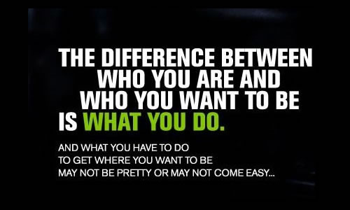

WHAT YOU DO IS WHO YOU WANT TO BE!

There are two categories of people, those who want more and those who settle for less. When it comes to fitness if you don’t aim for more you will get less. The higher your goals the greater will be the benefit.

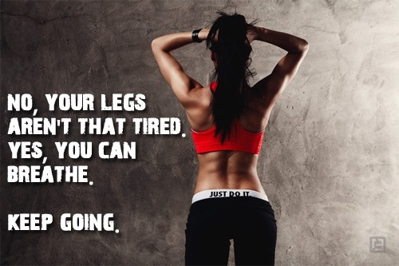

NO PAIN NO GAIN!

Muhammad Ali once said: “I don’t count my sit-ups; I only start counting when it starts hurting because they’re the only ones that count”. This process promises some real discomfort, but the rewards are far greater in the end!

A CHALLENGE IS A STEP TOWARDS GREAT CHANGE AND THE NEW YOU!

When faced with this challenge, you said “YES!” That was your about-face moment leading you down your new road!
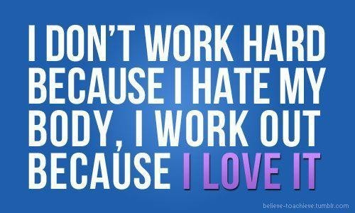

LOVE YOUR BODY AND WORK FOR IT!

The desire to change your body must be accompanied with LOVE! That’s right your body is unique and beautiful. It deserves a healthy diet and workout from you!

WANT IT? WORK FOR IT!

It’s not magic. After the step to do it you have to do the work that it requires. There is not magic wand in fitness or weight loss, but where there is a will, there is a way!

WHERE WILL YOU BE TOMORROW?
The choice will always be yours! If you lose your motivation, you can always RE-DECIDE. Just remember, that your choice today will lead you to your opportunity tomorrow!

